**Assignment – 2**

**Tasks To Be Performed:**

1. Use the previous deployment

2. Create a service of type NodePort for NGINX deployment

3. Check the NodePort service on a browser to verify

1. Created the YAML file for task and created a deployment

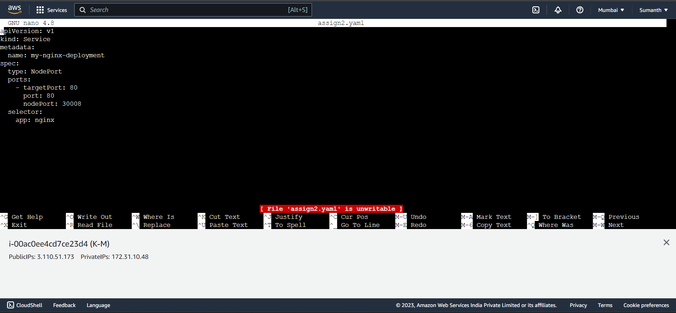

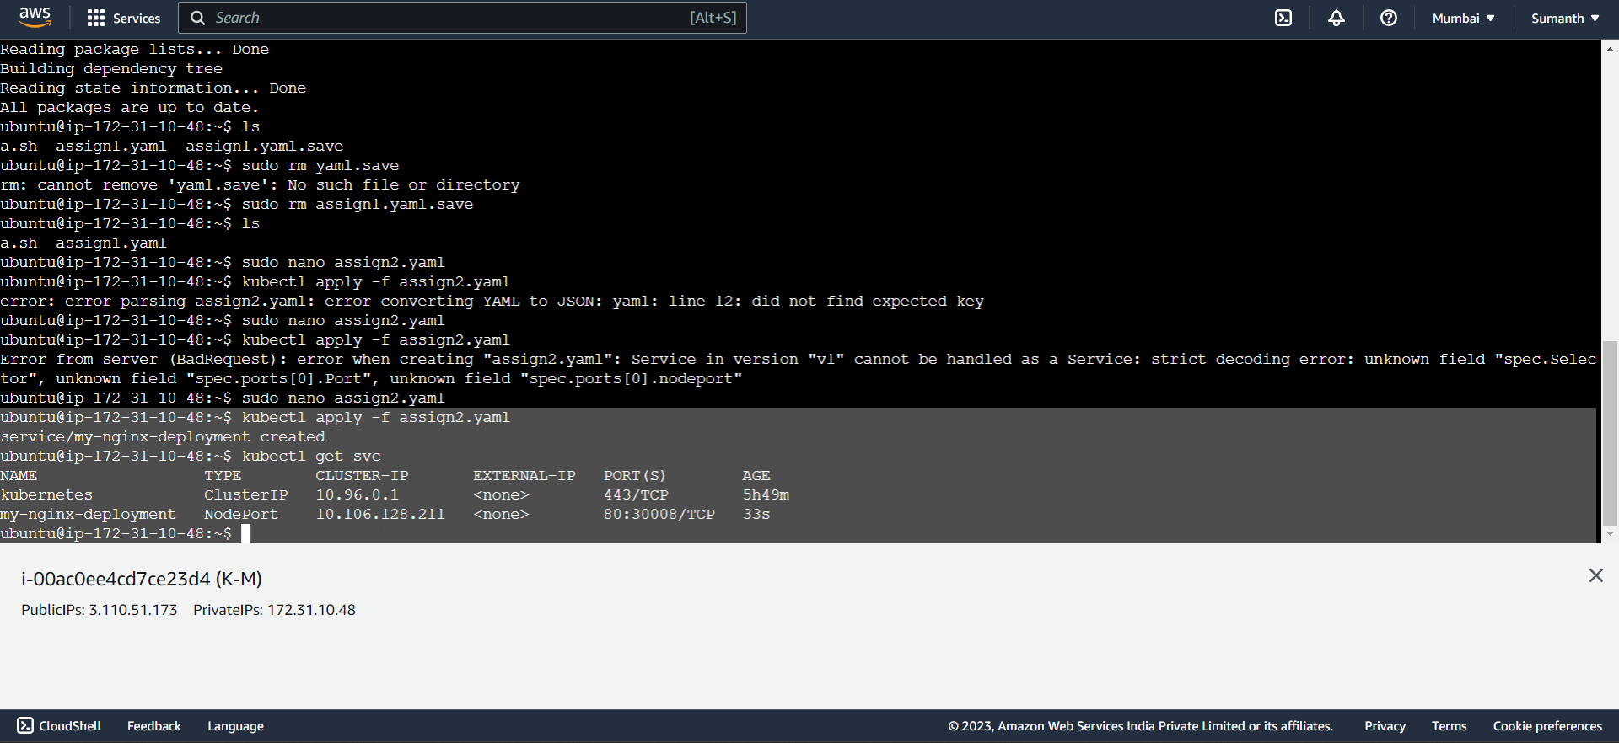

1. Checked the NodePort service on browser

